District 11 Grapevine Writing Workshop



February 17, 2024 10am – Noon

8391 Burnley Ct., Highlands Ranch, CO 80126

Speakers: Carole H., Ken O., and Bruce B.

Zoom ID:860 5649 8974

Passcode:050362

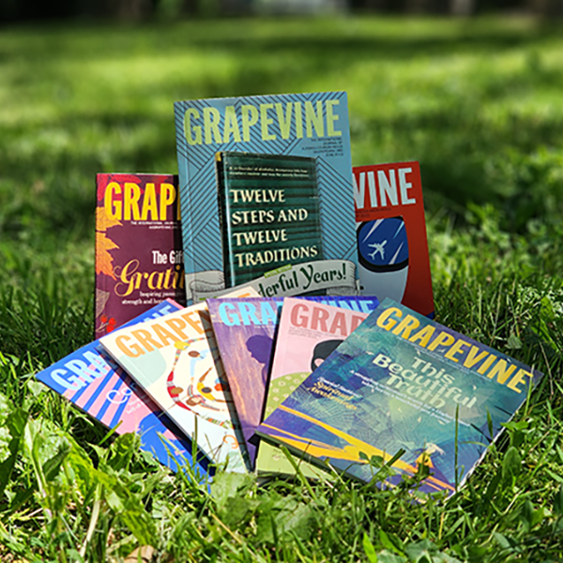

Contact: Maggie C. 303-506-0492(Text First) or [mabcaylor@hotmail.com](mailto:mabcaylor@hotmail.com)