Fellowship At The Foot Of The Flattop
Area 10 Spring Assembly 2024 - Grand Junction

March 22-24, 2024
DoubleTree Hotel
743 Horizon Drive
Grand Junction, CO
1-970-241-8888

Make hotel reservations by March 2, 2024 for discount rate ($119 per night)

PLEASE FOLLOW THIS LINK
or call the number above

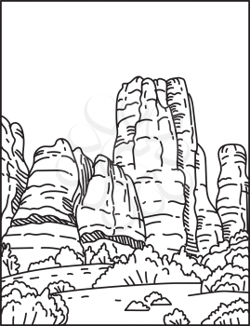

FREE Parking

Lunch Buffet | Saturday $19
Fellowship and Ice Cream | Saturday night $12
Coffee | By Donation ($10 suggested donation for the weekend)
Please pay onsite with cash or check

Open Saturday Speaker Meetings. Join Us!
Al-Anon Speaker at 7:00 PM
AA Speaker at 8:00 PM
Hosted by District 2 | Service Appointments Available
Contact Dena M at deeniemartini21@gmail.com

